Technical Architecture:

Project Design Phase-II Technology Stack (Architecture & Stack)

|  |  |
| --- | --- |
| Date | October 2022 |
| Team ID | PNT2022TMID30749 |
| Project Name | Skill and Job Recommender |

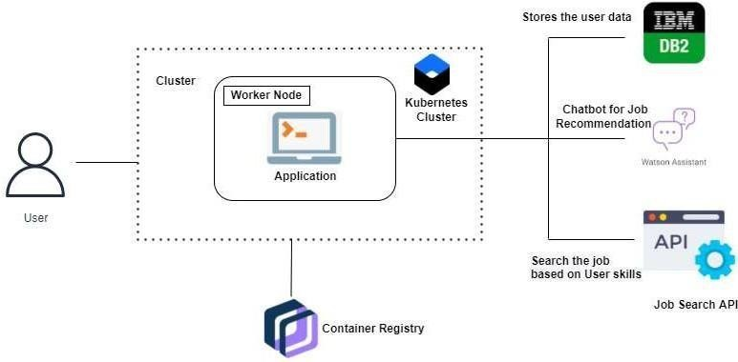

Table-1 : Components & Technologies:

|  |  |  |  |
| --- | --- | --- | --- |
| **S.No** | **Component** | **Description** | **Technology** |
| 1. | User Interface | How user interacts with application e.g. Web UI, Chatbot etc. | HTML, CSS, JavaScript |
| 2. | Search | Search for jobs using hybrid filtering | Python |
| 3. | Chat | Chat with Watson Assistant | IBM Watson Assistant |
| 4. | User Application | User applies for the desired company | Python Flask |
| 5. | Cloud Database | Database Service on Cloud | IBM DB2 |
| 6. | Job Search API | Job Search API is used for relevant results | Google Job Search API, etc. |
| 7. | Infrastructure (Server / Cloud) | Application Deployment on Local System / Cloud Local Server Configuration:  Cloud Server Configuration : | Local, Cloud Foundry, Kubernetes, etc. |

Table-2: Application Characteristics:

|  |  |  |  |
| --- | --- | --- | --- |
| **S.No** | **Characteristics** | **Description** | **Technology** |
| 1. | Open-Source Micro frameworks | Python Flask micro framework is used | Python Flask |
| 2. | Security Implementations | Mandatory Access Control (MAC) and Preventative Security Control is used | e.g. SHA-256, Encryptions, IAM Controls, OWASP etc. |
| 3. | Scalable Architecture | 3 – tier architecture | Web Server – HTML,CSS, JavaScript Application Server – Python  Database Server – IBM DB2 |
| 4. | Availability | Use of Load Balancing to distribute network traffic  across servers | IBM Load Balancer |
| 5. | Performance | (number of requests per sec, use of Cache, use of CDN’s) etc. | IBM Content Delivery Network |